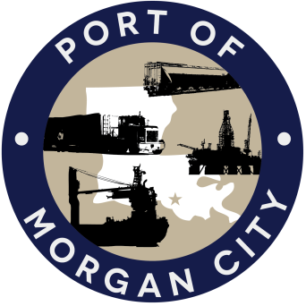

AGENDA

MORGAN CITY HARBOR AND TERMINAL DISTRICT
Regular Meeting of November 14, 2016 – 5:00 p.m. – 7327 Highway 182

- Call to Order

- Roll Call

- Invocation

- Pledge of Allegiance

- Minutes

Regular Meeting of October 10, 2016

- Finance Report
A. Presentation and discussion of financial reports for October 2016 – Deborah Garber
B. Invoices

Guest(s)/Public Comment
A. United States Coast Guard
B. Corps of Engineers, New Orleans District

Raymond “Mac” Wade - Executive Director’s Report

A. Randy Moertle, Randy Moertle and Associates, Inc.

B. Consultant – Michael Knobloch, Knobloch Professional Services, LLC
C. Consultant – Clay Breaud, Providence/GSE
D. Consultant – Mike Lowe, GHD Services
E. Cindy Cutrera, Manager of Economic Development

- Gerard Bourgeois - Legal Report

- New Business
A. Discussion and any action on Insurance Renewal Quotes from Paul’s Agency, LLC

- Old Business
A. Discussion and any action on leasing, improvements, maintenance and repairs to facility(ies), including Coast Guard lease(s)
B. Discussion and any action regarding the U.S. Department of Homeland Security grant program, including request for proposals, bids, purchases, project management, generators, computer data system and NOAA ports system(s).
C. Discussion and any action on Government Operations and Emergency Center including bids, purchases, change orders, inspection, payments, leasing and Facility Planning and Control
D. Discussion and any action on Atchafalaya River Channel dredging and sediment management, including survey services, consulting services and economic study(ies)
E. Discussion and any action on 2016 flood fight.
F. Discussion and any action regarding application to the Louisiana Port Construction and Development Priority Program for a Swiftships expansion port improvement project

- Adjournment

In accordance with the Americans with Disabilities Act, if you need special assistance, please contact Tori Henry at 985-384-0850, describing the assistance that is necessary.

